

*Tectonics*

Supporting Information for 2019TC005680

Cumulative and coseismic (during the 2016 Mw 6.6 Aketao earthquake) deformation of the dextral-slip Muji Fault, northeastern Pamir orogen

Tao Li1,2, Lindsay M. Schoenbohm3, Jie Chen1, Zhaode Yuan1, Wanpeng Feng2, Wenqiao Li4, Jianhong Xu1, Lewis A. Owen5, Edward R. Sobel6, Boxuan Zhang2, Wenjun Zheng2, Peizhen Zhang2

1State Key Laboratory of Earthquake Dynamics, Institute of Geology, China Earthquake Administration, Beijing, China

2Guangdong Provincial Key Lab of Geodynamics and Geohazards, School of Earth Sciences and Engineering, Sun Yat-sen University, Guangzhou, China

3University of Toronto Mississauga, Department of Chemical and Physical Sciences, Mississauga, Ontario, L5L 1C6, Canada

4Institute of Earthquake Forecasting, China Earthquake Administration, Beijing, China

5Department of Marine, Earth, and Atmospheric Sciences, North Carolina State University, Raleigh, 27695, USA

6Universitaet Potsdam, Institut für Erd- und Umweltwissenschaften, Karl-Liebknecht-Strasse 24, 14476 Potsdam, Germany

**Contents of this file**

Text S1

Figures S1 to S2

**Additional Supporting Information (Files uploaded separately)**

Dataset 1: submitted as a zip file

**Introduction**

This data set contains Text S1 and Figures S1-S2, which describe details of field sampling, laboratory preparation and measurement, and age calculation of terrestrial cosmogenic nuclide (TCN) 10Be samples collected from fluvial terraces at Akesayi site. ESRI shape files for the mapped surface of the Muji Fault are uploaded separately in Dataset 1 in a zip file.

**Text S1. TCN 10Be Dating: Sampling, Preparation, Measurement, and Age Calculation**

**1.1. Field Samping**

Exposure ages of terraces T3 and T2d are dated using TCN 10Be depth profile methods. On each terrace, we dug back >1 m and dug down ~2 m along the terrace edge to expose fresh fluvial deposits. Quartz and granite gravels with diameters of 1-4 cm (>30 clasts per depth) were collected and amalgamated from six layers with regular depth intervals (generally ~40 cm) (Table 1). For the terrace T2d, one pebble sample (>30 clasts) from the terrace surface was collected to date its age. The angle from the sample site to the top of surrounding mountain ridges was measured for the topographic shielding correction.

**1.2. Laboratory Preparation and Measurement**

Samples were prepared in the Cosmogenic Radionuclide Target Preparation Lab at University of Cincinnati (MJ1 and MJ2) and the Institute of Crustal Dynamics, China Earthquake Administration (MJ3). All rock samples were crushed, sieved and magnetically separated to obtain the nonmagnetic fraction of 250-500 μm size. This fraction was chemically leached using a minimum of six acid leaches: one 20% HCl leach for ~12 hours; four 5% HF/HNO3 leaches for ~12 hours; and one or more 1% HF/HNO3 leaches for ~12 hours. A heavy liquid (lithium heteropolytungstate or sodium polytungstate) separation was used after the first 5% HF/HNO3 leach. The purity of the quartz was tested using infrared stimulated luminescence in a Riso OSL Reader. The purified quartz was spiked with 0.2-0.5 mg ultrapure 9Be carrier, subsequently was dissolved in concentrated HF and then fumed three times with HClO4. The sample was then passed through anion and cation exchange columns to remove iron, aluminum, and other elements. NH3·H2O was added to the Be fractions to precipitate Be(OH)2 gel. Be(OH)2 was calcined at 920℃ for 10 minutes in muffle furnace. The resultant BeO was mixed with Nb power and loaded in steel targets for the measurement of the 10Be/9Be ratios by accelerator mass spectrometry at PRIME Laboratory in Purdue University. 10Be/9Be ratios were corrected using 10Be laboratory blanks (Table 1).

**1.3. Age Calculation**

The age and 10Be inheritance of each depth profile (MJ1 and MJ2) were calculated in the Monte Carlo simulator (Figures S1-S2 & 5; Hidy et al., 2010). We used a 10Be half-life of 1.387×106 years (Korschinek et al., 2010), a scaled production rate to our sample site using the scaling scheme of Lal (1991) and Stone (2000) and a reference production rate of 4.01±0.39 atoms/g/a (Sea Level High Latitude; Borchers et al., 2016), a density varying between 1.8 and 2.5 g/cm, and an attenuation length of 160 g/cm2 (Gosse and Phillips, 2001). A maximum surface-erosion depth of 10 cm and a maximum erosion rate of 2 cm/ka of the terrace surface were assigned, given that the terrace surface was quite young (<10 ka) and field observations suggested little erosion at the profile site. The age and inheritance are presented at the 95%-confidence level (Figure 5; Table 1).

For the surface sample MJ3, the age was calculated in the CRONUS-Earth online age calculator version-3.0 (Balco et al., 2008; [http://hess.ess.washington.edu/ math/](http://hess.ess.washington.edu/%20math/)), using the time-dependent scaling model (“Lm”; Lal, 1991; Stone, 2000), a density of 2.0 g/cm3, and an erosion rate of 0-2 cm/ka, and was corrected by the average 10Be inheritance of depth profiles MJ1 and MJ2 (Table 1).

**References**

Balco, G., Stone, J.O., Lifton, N.A., Dunai, T.J., 2008. A complete and easily accessible means of calculating surface exposure ages or erosion rates from 10Be and 26Al measurements. Quat. Geochronol. 3, 174-195. [http://doi:10.1016/j.quageo.2007.12.001](https://doi:10.1016/j.quageo.2007.12.001).

Borchers, B., Marrero, S., Balco, G., Caffee, M., Goehring, B., Lifton, N., Nishiizumi, K., Phillips, F., Schaefer, J., Stone, J., 2016. Geological calibration of spallation production rates in the CRONUS-Earth project. Quat. Geochronol. 31, 188-198. http://doi.org/10.1016/j.quageo. 2015.01.009.

Gosse, J.C., Phillips, F.M., 2001. Terrestrial in situ cosmogenic nuclides: theory and application. Quat. Sci. Rev. 20, 1475-1560.

Hidy, A.J., Gosse, J.C., Pederson, J.L., Mattern, J.P., Finkel, R.C., 2010. A geologically constrained Monte Carlo approach to modeling exposure ages from profiles of cosmogenic nuclides: an example from Lees Ferry, Arizona. Geochem. Geophys. Geosyst. 11, Q0AA10. <http://dx.doi.org/10.1029/2010GC003084>.

Korschinek, G., Bergmaier, A., Faestermann, T., Gerstmann, U.C., Knie, K., Rugel, G., Wallner, A., Dillman, I., Dollinger, G., Liersevon Gostmoski, Ch, Kossert, K., Maiti, M., Poutivtsev, M., Remmert, A., 2010. A new value for the half-life of 10Be by Heavy-Ion Elastic Recoil Detection and liquid scintillation counting. Nucl. Instrum. Meth. Phys. Res. B268, 187-191. http://dx.doi.org/10.1016/j.nimb.2009.09.020.

Lal, D., 1991. Cosmic ray labeling of erosion surfaces: in situ nuclide production rates and erosion models. Earth Planet Sci. Lett. 104, 424-439.

Stone, J.O., 2000. Air pressure and cosmogenic isotope production. J. Geophys. Res. 105 (B10), 23753-23823. http://10.1029/2000JB900181.

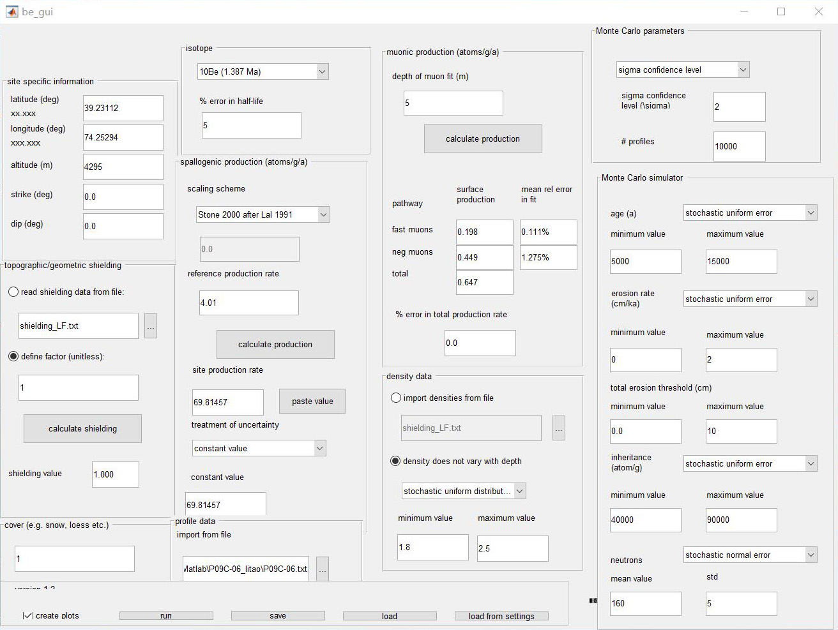

Figure S1. Parameters used in Monte Carlo modeling (Hidy et al., 2010) of depth profile samples MJ1.

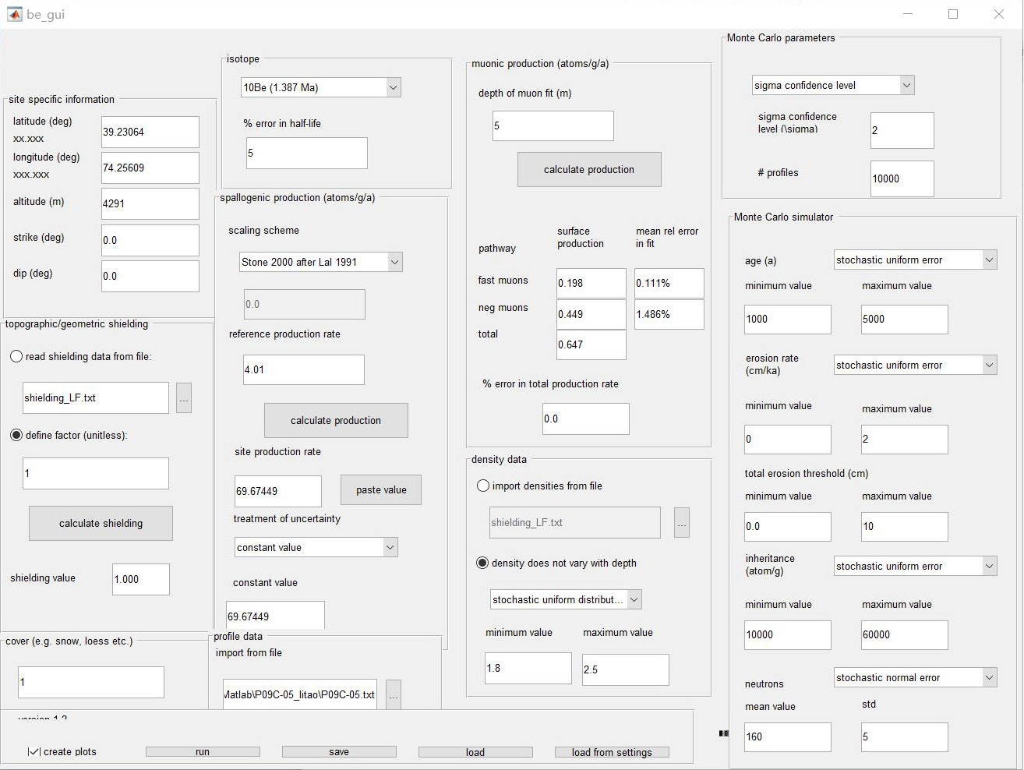

Figure S2. Parameters used in Monte Carlo modeling (Hidy et al., 2010) of depth profile samples MJ2.